Market research

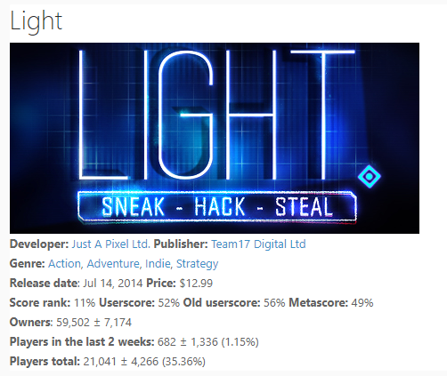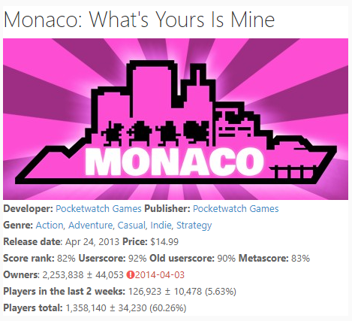

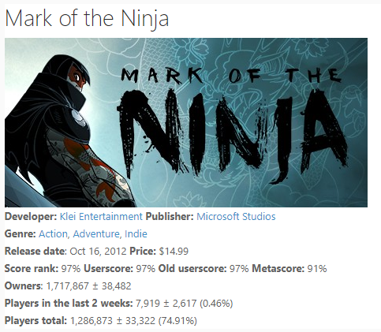41700 sales a month since release 1428 sales a month since release

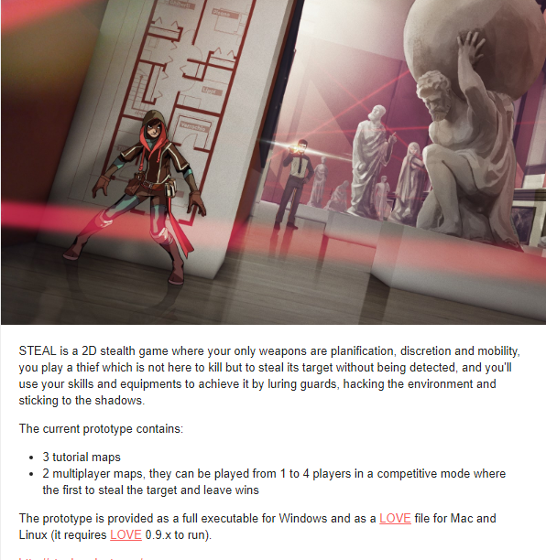

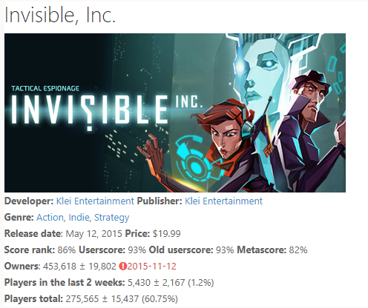28000 sales a month since release No Sales yet

15000 sales a month since release

The success of Monaco and Mark of the ninja show that well-made indie stealth games have a market, both selling mostly at $15. However the failure of Light shows that it is important to have a good leading story as these are complaints for it.

Steal is a game very similar to our concept but lacking the unique idea of cybernetic enhancements which allows us to introduce many different game mechanics. Steal is only in prototype at the moment, but also includes multiplayer where unlike